Global Directory

Major Project - II
(January 2009 – April 2009)



Submitted By:
Saurav Gupta
Department of Mathematics and Computing
Indian Institute of Technology, New Delhi

Supervised By:
Dr. Rajesh Bhat
Computer Services Center
Indian Institute of Technology, New Delhi

Certificate

This is to certify that the project titled “Global Directory” is a record of bonafide work carried out by Saurav Gupta (Entry No.: 2005JCA2425) under my supervision. To the best of my knowledge the work reported herein does not form part of any other project report or dissertation on the basis of which a degree or award was conferred on an earlier occasion to any other candidate.

Dr. Rajesh Bhat
Computer Services Center
Indian Institute of Technology
New Delhi-110016

Acknowledgement

It is my humble privilege to express my heartfelt thanks and deepest gratitude towards my project guide Dr. Rajesh Bhat (IIT Delhi) for his constant encouragement, inspiring guidance and for the co-operation extended by them which enabled me to submit this report. It was only due to his support and guidance that this work was possible. He has been actively interested in my work and has always been available to advise me. I feel deeply indebted to him for his patience, motivation, enthusiasm and valuable suggestions throughout the full year of the project work.

Saurav Gupta
(Entry No.: 2005JCA2425)
Department of Mathematics and Computing
Indian Institute of Technology
New Delhi-110016

TABLE OF CONTENTS
Certificate 2
Acknowledgement 3
1. ABOUT THIS DOCUMENT 1
1.1 Purpose 1
1.2 Objective 1
1.3 Scope 1
1.4 Organization of the Document 1
1.5 References 1
2. INTRODUCTION 2
2.1 Purpose of Project 2
2.2 Objectives of Project 2
2.3 Scope of Project 2
2.4 Scope Exclusion 2
2.5 Assumptions and Dependencies 2
2.6 Important Considerations 3
2.7 Technology Stack 3
3. Global Directory 4
3.1 Introduction 4
3.2 Domains 4
3.3 Personal Identification Numbers (PINs) 4
3.4 E-Governance 5
3.5 Fingerprint capturing and matching 5
4. Project Phases 6
5. KPIN Algorithms Analyzed 7
5.1 Requirement/Constraints 7
5.2 Algorithm Block Diagram 7
5.3 Algorithms Studied 8
5.4 Different Algorithms analyzed and Compression achieved. 8
5.5 KPIN Algorithm Implemented 9
6. Fingerprint Algorithms 11
6.1 Fingerprint Matching 11
6.2 Algorithm Selected 12
6.3 Fingerprint Enrollment 12
6.4 Fingerprint Verification 12
6.5 Quality and Matching Threshold 13
6.6 Current Status and Future Scope 13
7. Population Models 14
7.1 Matrix Population Model 14
7.2 Exponential Growth 14
7.3 Logistic Growth 15
7.4 Inter-specific Competition 15
7.5 Predation 16
8. System Design 17
8.1 System Architecture 17
8.2 Technical Architecture – MVC Architecture 18
9. Database Design 20
9.1 Database Tables 20
9.2 Stored Procedures 20
9.3 Database Diagram 21
10. UML Diagrams 22
10.1 Use Case Diagrams 22
10.2 Sequence Diagrams 24
11. Screen Designs 26
11.1 Fingerprint – Scanner Form 26
11.2 Fingerprint – Main Form 26
11.3 Login Page 27
11.4 Master Page 28
11.5 Home Page 29
11.6 Create your account 30
11.7 Family Details 31
11.8 Contact Details 32
11.9 Offspring Details 33
11.10 Sibling Details 34
11.11 Births in Family after 1989 34
11.12 Deaths in Family after 1989 35
11.13 Other Details 36
11.14 Change Password 37
11.15 Forgot Password 38
11.16 Search a Member 38
11.17 Mail Box 39
11.18 Send Message 40
11.19 Send Mail 40
11.20 Approve/Reject Request 41
11.21 Link to KPIN 42
11.22 Generate Reports 42
11.23 View Family Tree 43
11.24 Upload your photo 44
11.25 Error Page 44
12. Screenshots 46
12.1 Login Page 46
12.2 Header/Master Page 46
12.3 Home Page 47
12.4 Family Details 47
12.5 Sibling Details 48
12.6 Search a Member 48
12.7 Create new account 49
12.8 Upload your photo 49
12.9 Org chart 50
12.10 Link to KPIN 50
13. Secured Communications 52
13.1 Message to an Individual 52
13.2 Message to a Group 52
14. Applications 54
15. Salient Features 55
16. Conclusion 56

This document contains a total of 40 pages

ABOUT THIS DOCUMENT

Purpose

The purpose of this document is to provide the approach and the work accomplished in the assigned Project with the Title “Global Directory”.

Objective

The objectives of this document are:
- To provide the algorithm implemented to Generate KPIN.
- To establish the real-time use of the System for e-governance
- To establish the features which can be explored by its member

Scope

The document is prepared, keeping in mind the above objectives.
This document restricts itself to –
- Algorithms Analyzed / Implemented
- Generate reports to analyze the population statistics for e-governance
- Generation of family tree and other features for a member

Organization of the Document

The structure of the document is as follows:
- Section 1 describes the purpose, objectives, scope and abbreviations used in this document.
- Section 2 gives the Introduction to the Project.
- Section 3 describes the Implementation Strategy
- Section 4 provides the pseudo codes for the Algorithms implemented and the implemented Strategy.
- Section 5 provides the observation/analysis of Algorithms
- Section 6 provides the scope for improvements

References

- VB 2005 with .NET 2.0 – By Bill Evjen, Bill Hollis, Bill Sheldon, Kent Sharkey
- Introducing Microsoft® SQL Server™ 2005 for Developers - Peter DeBetta

INTRODUCTION

Purpose of Project

The purpose of the Project is to create a directory of personal information of an individual, and too stored in Database in secured Environment.
The directory can be used by its member to view the family tree, to contact friends and to establish links. Also the data captured can be utilized for e-governance by generating reports on population statistics.

Objectives of Project

The Key objectives are
- System to capture personal information of an Individual.
- System which can be used for Data Analysis or by Census.
- Secured data storage
- Secured Mechanism of contacting your friends and to send messages.
- Generate algorithm to stored information in cryptic format.

Scope of Project

The current scope is limited to
- Analyze/Implement the algorithms to store information in cryptic and compressed form in Database.
- Create forms to collect data.
- Provide Secured Mechanism to contact your friends
- Provide functionality to upload photos/ fingerprints
- Generate reports for population statistics
- View the family tree for a member
Presently, the implementation is done for a single community.

Scope Exclusion

The scope excludes its integration with other systems for information on Birth/Death details in a year and also for Immigration/Emigration details.

Assumptions and Dependencies

- Information entered by member is correct and accurate.
- System cannot check for the authenticity of the entered information.
- Regular Data verifications can be done to check for data authenticity.
- The source of information can be the other systems.

Important Considerations

Some of the important factors to be considered while implementing it:
- Secured Mechanism
- Complexity of Algorithms
- Data storage
- Easy to use

Technology Stack

Hardware

Hardware Configuration : IBM PC’s 80 GB HDD 1 GB RAM
Operating System : Windows XP Professional

Software

Software : VS 2005 Developer Edition
Programming Language : VB.NET, .NET Framework 2.0 (ASP.NET)
Databases : SQL Server 2005
Tools : Effexis Sequence Diagram Editor, Crystal Reports

Global Directory

Introduction

The Global Directory is an online directory of personal information divided in Public and Private Domain made accessible to community of users. The users can add varied personal details, family details etc. The information is accessible to members only with valid Key Personal Identification Number (K-PIN) or User ID generated automatically from the personal information entered while signing-up.

We would generate two unique PINs for each member, one K-PIN based on some compulsory/key public domain information and other V-PIN (Variable Personal Identification Number) based on variable personal information in private domain.

This system allows user to contact other members via secured mechanism that is without sharing any personal information.

The system also helps in E-governance by studying the family chart and also from the population statistics. Based on the analysis, the appropriate action can be taken to improve the living standard of the community.

Domains

The complete information is divided into two domains

- Public Domain:
The Public Domain contains the Key information of an individual (like Name, DOB, etc...). The Key information is not updateable and can be shared with other member.

- Private Domain:
The Private Domain contains the variable information of an individual (like Sibling details, property details, etc...). This information is updateable and access to this information is restricted.
This information collected can be used for Analysis purposes like to find the average age of the community.

Personal Identification Numbers (PINs)

The PIN is an identification number generated for each member. For each member, following two PINs are generated:

- KPIN (Key PIN):
For the Public Domain information, the KPIN is generated based on following key information.
- Name, Fathers Name, Mothers Name, DOB

- VPIN (Variable PIN):
For the Private Domain information, the VPIN is generated based on the variable information of a member.
- Sibling Details, Offspring Details, Property Details etc...

E-Governance

E-Governance is a network of organizations to include government, nonprofit, and private-sector entities; in e-governance there are no distinct boundaries.
The model for e-governance is a one-stop portal, where citizens have access to a variety of information and services. An ideal portal would be one for employment where a citizen creates a profile and is presented with employment opportunities at the federal, state, local, non-profit, and private-sectors; currently websites like monster.com over these services but more often than not users are required to reenter their information for the specific job. However, not all stakeholders have the same desired end-state which inhibits the possibility of a one-stop portal.
E-Government (short for electronic government, also known as e-gov, digital government, online government or transformational government) is a diffused neologism used to refer to the use of information and communication technology to provide and improve government services, transactions and interactions with citizens, businesses, and other arms of government.

The primary delivery models of e-Government can be divided into:
- Government-to-Citizen or Government-to-Customer (G2C)
- Citizen-to-Government
- Government-to-Government (G2G)
- Government-to-Employees (G2E)

The study of different population models provides a good measure of future population. And also it helps in analyze the population after years and based on that we can take steps now to control that.

Fingerprint capturing and matching

A fingerprint is an impression of the friction ridges of all or any part of the finger. Fingerprint recognition systems use characteristics from these ridges (they are also called fingerprint features) to differentiate one fingerprint from another.
A Fingerprint is a good means to differentiate two members and the integration of Global Directory with fingerprint application can be used to uniquely identify the members of group.

Project Phases

To meet the project objectives within the given time frame, the project is implemented in the following phases:
- Study and Acquire Knowledge
- Analyzing Algorithms
- System Designing
- Implementation

A well-defined process is followed during each of these phases of the project. The essence of the process is a structured method of process control using checklists of activities with specific Entry criteria, Tasks, Validation procedures, and exit criteria (ETVX).

Study and Acquire Knowledge | Analyzing Algorithms | System Designing | Implementation
- Define Scope of Project  - Study of different existing Compression and Encoding Techniques  - Collect information related to Fingerprint storage and matching  - Study of different population Models for analysis | - Compare different algorithms  - Come-up with the appropriate algorithm for compressed data storage.  - To customize the existing Fingerprint matching algorithms to suit our needs. | - Design Database Architecture  - Design Layout of Pages for data analysis  - Changes required for fingerprint matching  - Design reports for population statistics | - Implement the KPIN generation Algorithm.  - Implement Fingerprint matching algorithm  - Create forms for data representation and analysis  - Develop reports for population statistics and for population models for e-governance

KPIN Algorithms Analyzed

As there is a need to compress the database information to reduce the data storage and to provide the high data security, so to achieve that several existing algorithms are studied and analyzed to for their appropriateness. The algorithms requirement/constraints are highlighted below.

Requirement/Constraints

As per the requirement, we need to perform the compression and encoding of the data and to store all the information in cryptic format.
But data storage in cryptic format is not the only constraint. For generating KPIN, we need to restrict the length of the KPIN (Username) also as the member has to remember and enter it on the portal to login into Global Directory. So the length of the KPIN is restricted to 10 so that all alphabets of KPIN are enterable from keyboard and can be remembered easily.
Considering that we have to generate 10 characters KPIN, we can store 36¹⁰ members in the directory and if required, we can increase the characters limit.

Algorithm Block Diagram

To perform the operation specified in the above section, we decided that we will work on the strategy depicted in the below figure.

Information
Compression
Encoding
KPIN / VPIN
PIN Generation
Decompression
Decoding
Information regeneration from KPIN
Information

Algorithms Studied

Several existing algorithms are studied to achieve the Compression/Encoding of data and to generate the PINs but each of them has some limitation. Few are mentioned below:
- During compression, there is some loss of information.
- The characters representing the compressed form are not enterable characters
- The Length of the encoding technique used has no limit on length of characters.
- The Length of compressed string may vary with the data and can cross our initial limit of 10 characters of KPIN.

Under the constraints mentioned above, we decided to generate our own algorithm to generate the PIN IDs.

Different Algorithms analyzed and Compression achieved.

- Use of suffix trees to compress
A suffix tree (also called suffix trie, PAT tree or, in an earlier form, position tree) is a data structure that presents the suffixes of a given string in a way that allows for a particularly fast implementation of many important string operations.
The suffix tree for a string S is a tree whose edges are labeled with strings, and such that each suffix of S corresponds to exactly one path from the tree's root to a leaf. It is thus a radix tree (more specifically, a Patricia trie) for the suffixes of S.

Using suffix tree, we can achieve some level of compression by representing the redundant numbers/characters by numerals. We tied to work out using suffix trees but this does not provide desired compressions and moreover, this leads to inconsistencies and also reduction is not much.

- Tertiary System (tits)

The tertiary numeral system, or base-3 number system represents numeric values using three symbols, 0, 1 and +. More specifically, the base-3 system is a positional notation with a radix of 3.
To achieve compression, we tried converting the ASCII values to tertiary system, but this provides compression up to 20% only but not enough as per the requirement.

- Quad System (Qits)

The Quad numeral system, or base-4 number system represents numeric values using four symbols, 0, 1, - and +. More specifically, the base-4 system is a positional notation with a radix of 4.
To achieve compression, we tried converting the ASCII values to quad system, but this provides compression up to 25% only but not enough as per the requirement.

- XOR Approach – Selected Approach

Considering the limitation on the number of enterable characters for KPIN, it is evident that the greater compression is not practically feasible. So to achieve some level of compression we split the string of binary codes into two strings, and then perform XOR, subtraction option and now using Quad System, we can achieve compression up to 40%.

KPIN Algorithm Implemented

KPIN is generated from Name, Mothers Last Name and Date of Birth. The KPIN Algorithm as follows:

KPIN Encoding
- Convert the Date of Birth (DOB) to a numeric Number by taking 01-01-1900 as the reference date. This will convert the string of length 10 to a numeric number which will definitely be less than 10. Thus providing some compression before we actually implement the KPIN Algorithm.
For example: If date is 25 March, 1983 then it is converted to 30398.
- The Member Name and Mothers Last name contains only the characters ranging from A to Z and can have some special symbols, space and delimiter to pad the Name to 30 characters and Mothers Last name to 15 characters. Convert the non-delimiter character to (ASCII value – 65) and space by 27.
During the conversion, if we come across any delimiter character (-) then count the number of such characters.
- The Sequence of string formed is DOB, Name and Mothers Last name.
- Convert DOB to binary bits
- Convert the concatenated string of Name and Mothers Last Name to binary bits by considering that each character can be represented by 5 bit.
- Concatenate the DOB, Name and Mothers Last name in the specified sequence.
- Prefix the binary coded string such that the length of the string is a factor of 6.
- Now split the string in two strings of equal length = (length of binary coded string / 2).
- Now apply the XOR operation such that
  - If String1 = ‘0’ & String2 = ‘0’, then new string code = ‘0’
  - If String1 = ‘1’ & String2 = ‘1’, then new string code = ‘1’
  - If String1 = ‘0’ & String2 = ‘1’, then new string code = ‘-’
  - If String1 = ‘1’ & String2 = ‘0’, then new string code = ‘+’
- Now replace the coded string using the Quad System.
- The Coded string generate is KPIN

For example:
If Date of Birth = ’25 March 1983’, then DOB = 30398
Name = Saurav Gupta
Mothers Last name = Gupta

Encoded Binary String = 0111011010111110010110010000001010010001000001010111011001101010001111100110000010010001101010001111100110000001010

Encoded KPIN = C7|N@4UM]EC6EO%5&M.H

KPIN Decoding
- Convert the Encoded KPIN to the string in Quad System as per the Look-up table.
- Now Apply the XNOR operation on the Quad System string to generate two binary coded strings such that
  - If string code = ‘0’ then String1 = ‘0’ & String2 = ‘0’
  - If string code = ‘1’ then String1 = ‘1’ & String2 = ‘1’
  - If string code = ‘-’ then String1 = ‘0’ & String2 = ‘1’
  - If string code = ‘+’ then String1 = ‘1’ & String2 = ‘0’
- Concatenate the two strings in sequence String1+String2 to form a single binary coded string for the encoded KPIN.
- Now to generate back the data, we need to decode data from right.
- Pick the last 5 digits and convert it to a numeral and this will give the number of delimiters (-) in Mothers Last name. Then Number of characters in Mothers Last Name = 15 – No. of delimiters.
Pick the number of bits = 5*(Number of characters in Mothers Last Name) and convert them to characters and replace the delimiters by (-)
- Similarly, perform the decoded operation for name by picking the last 5 bits to find number of delimiters and then calculate number of characters in Name = 15 – No. of delimiters in Name.
Number of bits in Name = 5*(Number of characters in Name) and convert them to characters.
- Convert the remaining bits in the binary coded string to get the DOB.
- Now form a concatenated string of DOB, name and Mothers Last name.
- We can now remove the delimiters by replacing it with blank spaces thus getting the data back from KPIN.

For example:
Encoded KPIN = C7|N@4UM]EC6EO%5&M.H
Decoded String = 30398-----SAURAV GUPTA------------------GUPTA----------

Since DOB = 30398, therefore the corresponding Date of Birth = 25-March-1983
Name = Saurav Gupta; and Mothers Last name = Gupta

Fingerprint Algorithms

A fingerprint is an impression of the friction ridges on all parts of the finger. A friction ridge is a raised portion of the epidermis on the palmar (palm) or digits (fingers and toes) or plantar (sole) skin, consisting of one or more connected ridge units of friction ridge skin. These are sometimes known as "epidermal ridges" which are caused by the underlying interface between the dermal papillae of the dermis and the interpapillary (rete) pegs of the epidermis. These epidermal ridges assist in gripping objects and may also serve to amplify vibrations triggered when fingertips brush across an uneven surface, better transmitting the signals to sensory nerves involved in fine texture perception.

Fingerprint Matching

Fingerprint matching techniques can be placed into two categories: minutae-based and correlation based. Minutiae-based techniques first find minutiae points and then map their relative placement on the finger. However, there are some difficulties when using this approach. It is difficult to extract the minutiae points accurately when the fingerprint is of low quality. Also this method does not take into account the global pattern of ridges and furrows. The correlation-based method is able to overcome some of the difficulties of the minutiae-based approach. However, it has some of its own shortcomings. Correlation-based techniques require the precise location of a registration point and are affected by image translation and rotation.
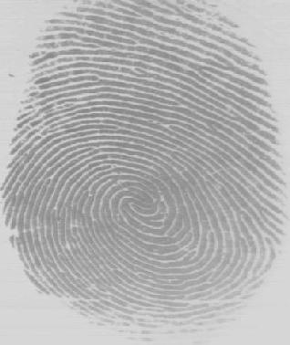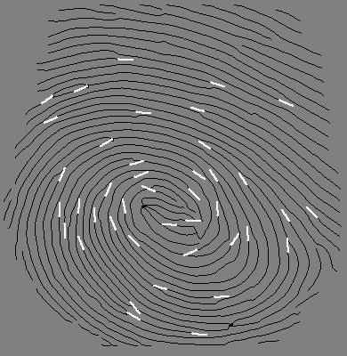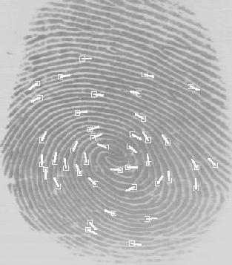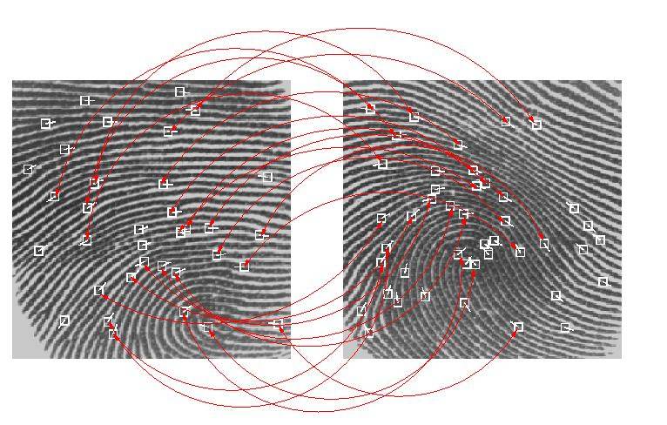
Fingerprint matching based on minutiae has problems in matching different sized (unregistered) minutiae patterns. Local ridge structures cannot be completely characterized by minutiae. There is an alternate representation of fingerprints which will capture more local information and yield a fixed length code for the fingerprint. The matching will then hopefully become a relatively simple task of calculating the Euclidean distance will between the two codes.
A commercial fingerprint-based authentication system requires a very low False Reject Rate (FAR) for a given False Accept Rate (FAR). This is very difficult to achieve with any one technique. In a real application, the sensor, the acquisition system and the variation in performance of the system over time is very critical.

Algorithm Selected

The Complexity of Fingerprint Capturing and Matching is very high and the efforts involved is also high and considering the complexity of the algorithm and process, the integration will be done using the existing algorithms.
To implement the Fingerprint Matching, we referred to Fingerprint SDK – VeriFinger. This allows developing a wide range of biometrical applications that identify fingerprints taken from fingerprint. The SDK does not allow developing applications that read fingerprint images from files.
The Pre-sorting database entries using certain global features reduce faster matching of fingerprints. In the Henry system of classification, there are three basic fingerprint patterns: Arch, Loop and Whorl.

Fingerprint Enrollment

Enrollment is the process of capturing a person's fingerprint (using a fingerprint capture device). During the enrollment process the system saves member's fingerprint to a database.
When enrolling features from a finger are extracted and saved as a fingerprint template for a future comparison against other fingerprint templates. The following instructions describe a typical fingerprint enrollment scheme:
- Capture a person's fingerprint using a fingerprint scanner
- Extract a fingerprint features from a fingerprint image
- Associate member’s fingerprint with his KPIN
- Save extracted features (a template) to a database

Fingerprint Verification

Verification is the process when a captured fingerprint is compared to an enrolled fingerprint in order to determine whether the two match.
During a verification a scanned fingerprint is compared with the one saved to a database and is decided whether the two match. The following scheme is used for fingerprint verification:
- Capture a person's fingerprint using a fingerprint scanner.
- Extract a fingerprint features from a fingerprint image for the purpose of verification.
- Get a fingerprint template from database by KPIN and compared with extracted features.

Quality and Matching Threshold

Quality threshold is the property that defines a scanned fingerprint image quality. Quality threshold should be in range [0, 255]. If 255 is set, then only image with best quality threshold will be allowed.
The default quality threshold value is 100.

Quality threshold can be in these ranges:
- [0, 99] - Low quality
- [100, 199] - Medium quality
- [200, 255] - High quality.

Matching threshold is the minimum similarity value that verification and identification functions accept for the same fingerprints. Matching threshold can be varied according to the system's development requirements.
The default value is 48.

Current Status and Future Scope

We started with the implementation of Fingerprint Capturing and matching but due to high complexity, we switched to Fingerprint SDK which provides a good platform to build applications on top of it. The application current allows you to store fingerprints in the database with some restriction. Due to unavailability of scanner, the testing is not thoroughly done.

Population Models

Population models are used in population ecology to model the dynamics of wildlife or human populations. The different Mathematical Model for population growth is presented here.

Matrix Population Model

Matrix population models are a specific type of population model that uses matrix algebra. Matrix algebra, in turn, is simply a form of algebraic shorthand for summarizing a larger number of often repetitious and tedious algebraic computations. All populations can be modeled by one simple equation:
N(t+1) = N(t) + B - D + I - E,
Where N(t+1) = abundance at time t+1
N(t) = abundance at time t
B = number of births within the population between times t and t+1
D = number of deaths within the population between times t and t+1
I = number of individuals immigrating into the population between times t and t+1
E = number of individuals emigrating from the population between times t and t+1
This equation is called a BIDE model. Although BIDE models are conceptually simple, reliable estimates of the 5 variables are often difficult to obtain. Usually a researcher attempts to estimate current abundance, Nt, often using some form of mark and recapture technique.
Estimates of B might be obtained via a ratio of young to adults soon after the breeding season, Ri.
Number of deaths can be obtained by estimating annual survival probability, usually via mark and recapture methods, then multiplying present abundance and survival rate.
Many times immigration and emigration are ignored because they are so difficult to estimate.

Exponential Growth

Under simplified conditions, such as a constant environment (and with no migration), it can be shown that change in population size (N) through time (t) will depend on the difference between individual birth rate (b₀) and death rate (d₀), and given by:
dN/dt = (b₀ - d₀) / N₀ (equation 1)
Where b₀ = instantaneous birth rate, births per individual per time period (t).
d₀ = instantaneous death rate, deaths per individual per time period, and
dN₀ = current population size.
The difference between birth and death rates (b₀ - d₀) is also called r, the intrinsic rate of natural increase, or the Malthusian parameter. It is the theoretical maximum number of individuals added to the population per individual per time. By solving the above equation we get a formula to estimate a population size at any time:
N = N₀e^{rt}, where e = 2.718... (Base of natural logs).
This equation shows us that if birth and death rates are constant, population size will grow exponentially.

Logistic Growth

We need to modify the basic equation 1 so that birth and death rates are no longer constant through time, but decrease and increase respectively as population size increases
dN/dt = N [(b₀ - k_{b}N) - (d₀ + k_{d}N)] (equation 2)
Where k_{b} and k_{d} are the density-dependent birth and death rate constants respectively.
This equation predicts that a population will stop growing (zero population growth) when birth rate equals death rate, or
b₀ - k_{b}N = d₀ + k_{d}N
This can be converted into an equation showing the size at which the population reaches a steady state:
N = (b₀ - d₀) / (k_{b} + k_{d})
Since b₀ - d₀ = r. If we combine this new form of the carrying capacity equation with equation 2 we get the familiar form of the logistic growth equation:
dN/dt = rN [(K - N) / K] (equation 3)

Inter-specific Competition

Mathematically, competition between species is treated as another density-dependent effect on the carrying capacity for each species. In the logistic equation 2, the density-dependent birth and interspecific competition is introduced as the number of individuals in one population increase, birth and death rates change because resources become limiting.
To incorporate the effects of interspecific competition include a competition term in the logistic equation 3. For the purposes of the model, competition now becomes defined as "the amount by which Species 1 lowers the K of Species 2, and vice versa," so that there are two competition coefficients for a two-species system. Now incorporate a competition coefficient,
dN₁/dt = r₁N₁ [(K₁ - N₁ - N₂) / K₁]
Where is the number of individuals of competing Species 2 which are equivalent to Species 1. Similarly, for Species 2, is the strength of competition it experiences from Species A, incorporated as:
dN₂/dt = r₂N₂ [(K₂ - N₂ - N₁) / K₂]
where K₁ and K₂ = carrying capacity for each species when grown separately,
r₁ and r₂ = intrinsic rates of growth for each species when grown separately,
N₁ and N₂ = numbers of each species in a mixed culture at a particular time period, and
dN₁/dt and dN₂/dt = instantaneous growth rate of each species when grown together during time period t.

There are four possible outcomes of a two species competitive interaction, as follows:
- Species 1 will be eliminated when: > K1/K2 and < K2/K1
- Species 2 will be eliminated when: < K₁/K₂ and > K₂/K₁
- Coexistence of both species when: < K₁/K₂ and < K₂/K₁
- Which species survives depends on the relative sizes of the starting populations when: > K₁/K₂ and > K₂/K₁

Predation

The simplest model for predation is the Volterra predator-prey equation which has two parts. The change in prey population through time is described by:
dV/dt = rV - (aV)P, and
the change in predator population size through time is:
dP/dt = b(aV)P - d₀P
Where V = size of prey population (victim), P = size of predator population,
r = intrinsic rate of increase of prey, a = predator feeding rate,
b = efficiency factor of predator, and d₀ = death rate of predators.
The efficiency factor, b, measures how well the predator converts food into offspring.
A less efficient predator will expend more of its energy on maintenance than on reproduction compared to an efficient predator. This model is simplistic because it assumes exponential growth of prey, and a predator can eat as much prey as it can catch -- that is, it never gets full!

System Design

System Architecture

Database
Client Server –
Web Browser

Web Server
Request for page
Request for data
Received Data
HTML Page with required contents
Client-Server Model
The Client-Server software architecture model distinguishes client systems from server systems, which communicate over a computer network. A client-server application is a distributed system comprising both client and server software. A client software process initiates a communication session, while the server waits for requests from any client.
Client/server describes the relationship between two computer programs in which one program, the client, makes a service request from another program, the server. Each instance of the client software can send data requests to server. In turn, the servers can accept these requests, process them, and returns the requested information to the client.
This type of architecture is referred to as two-tier. The two tier architecture means that the client acts as one tier and application in combination with server acts as another tier.
A Web Browser is a client program at the user computer that may access information at any web server in the world. It allows a user to quickly and easily access information provided on many Web pages. Web browsers format HTML information for display, so the appearance of a Web page may differ between browsers.

Characteristics of a Web browser
- Initiates requests
- Waits for replies
- Receives replies
- Usually connects to a small number of servers at one time
Typically interacts directly with end-users using a graphical user interface
A Web Server is a computer program that is responsible for accepting HTTP requests from W, and serving them HTTP responses along with optional data contents, which usually are web pages such as HTML documents and linked objects (images, etc.).

Characteristics of a server

Never initiates requests or activities

Waits for and replies to requests from connected clients

A server can interact with Database to fetch data. We can have a separate Database Server for data access. A database server is a computer program that provides database services to other computer programs or computers, as defined by the client-server model.

The Client-Server architecture has the following benefits:
- In most cases, a client-server architecture enables the roles and responsibilities of a computing system to be distributed among several independent computers that are known to each other only through a network. This creates an additional advantage to this architecture: greater ease of maintenance.
- All the data is stored on the servers, which generally have far greater security controls than most clients.
- Since data storage is centralized, updates to that data are easier to administer.
- It functions with multiple different clients of different capabilities.

To create/update your account from your computer, a web browser client program in your computer forwards your request to a web server program. That program may in turn forward the request to its own database client program that sends a request to a database server to retrieve information. The information is returned to the client, which in turn serves it back to the web browser client in your personal computer, which displays the information.

Technical Architecture – MVC Architecture

The goal of the MVC design pattern is to separate the application object (model) from the way it is represented to the user (view) from the way in which the user controls it (controller).
- Model: The model object knows about all the data that need to be displayed. It is model who is aware about all the operations that can be applied to transform that object. It only represents the data of an application. The model represents enterprise data and the business rules that govern access to and updates of this data. Model is not aware about the presentation data and how that data will be displayed to the browser.
- View: The view represents the presentation of the application. The view object refers to the model. It uses the query methods of the model to obtain the contents and renders it. The view is not dependent on the application logic. It remains same if there is any modification in the business logic. In other words, we can say that it is the responsibility of the view's to maintain the consistency in its presentation when the model changes.
- Controller: Whenever the user sends a request for something then it always go through the controller. The controller is responsible for intercepting the requests from view and passes it to the model for the appropriate action. After the action has been taken on the data, the controller is responsible for directing the appropriate view to the user. In GUIs, the views and the controllers often work very closely together.

The MVC architecture has the following benefits:
- Multiple views using the same model: The separation of model and view allows multiple views to use the same enterprise model. Consequently, an enterprise application's model components are easier to implement, test, and maintain, since all access to the model goes through these components
- Easier support for new types of clients: To support a new type of client, you simply write a view and controller for it and wire them into the existing enterprise model.
- Clarity of design: By glancing at the model's public method list, it should be easy to understand how to control the model's behavior. When designing the application, this trait makes the entire program easier to implement and maintain.
- Efficient modularity: The design allows any of the components to be swapped in and out as the user or programmer desires - even the model! Changes to one aspect of the program aren't coupled to other aspects, eliminating many nasty debugging situations. Also, development of the various components can progress in parallel, once the interface between the components is clearly defined.
- Ease of growth: Controllers and views can grow as the model grows; and older versions of the views and controllers can still be used as long as a common interface is maintained.
- Distributable: With a couple of proxies one can easily distribute any MVC application by only altering the startup method of the application.

Database Design

Database Tables

Table Name | Purpose
MemberInfo | This table contains basic information of Member. (Name, Age)
ContactDetails | This table contains the contact information of member (Address, Contact No., Email Id)
FamilyDetails | Contains parental details: Father’s/ Mothers Name
SiblingDetails | Contains Sibling details
OffspringDetails | Contains Offspring details
Birthsafter1989 | Contains information of Birth in Family after 1989
Deathsafter1989 | Contains information of Death in Family after 1989
PropertyDetails | Add Property details of member
OtherDetails | Add other member details like Education, Employment details
MailList | List of all mails sent from one member to another mail via secured mechanism.
RequestforPublicMessage | Stores Request pending/answered by administrator for sending message to a Group
ArchivedRequests | Archived Messages Approved/Rejected by administrator
AdminAccess | Provide Administrator access to member for approval/rejection of request or to archive requests
Images | Stores Images of Member

Stored Procedures

Stored Procedure | Purpose
FamilyKPIN | Returns the list of all family members with the associated KPINs
LinkKPIN | To Link the family members to KPIN
OrgChart | Returns data to generate Family Tree
Reports | Returns data to generate reports for population statistics

Database Diagram

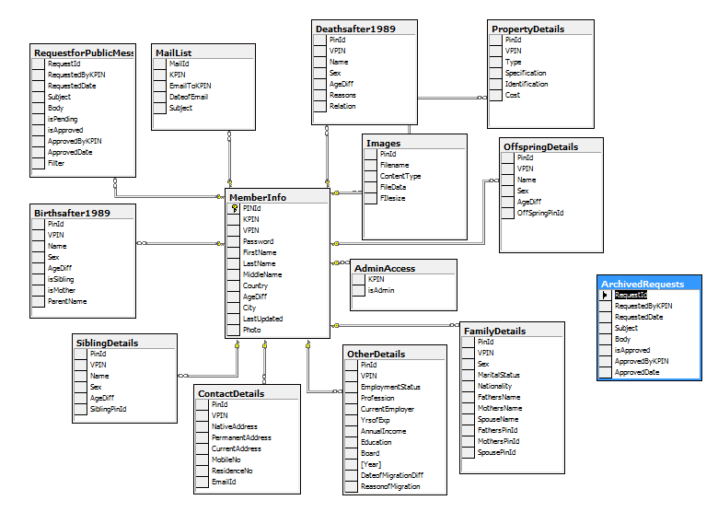

UML Diagrams

The Unified Modeling Language (UML) is a standard language for specifying, visualizing, constructing, and documenting the artifacts of software systems, as well as for business modeling and other non-software systems. The UML represents a collection of best engineering practices that have proven successful in the modeling of large and complex systems. The UML is a very important part of developing objects oriented software and the software development process. The UML uses mostly graphical notations to express the design of software projects.

Use Case Diagrams
User
Create an account
Update your personal Details
Search your friend
Send Message to an Individual
Send Message to a Group
Get KPIN
View your family tree

User - Admin
Generate Reports for Population Analysis
Keep a check on Portal
Approve Broadcasted Messages
Archived the Broadcasted Messages
View family tree for any member

Sequence Diagrams

The interaction between client and server is often described using sequence diagrams. Sequence diagrams are standardized in the Unified Modeling Language.

Create an Account

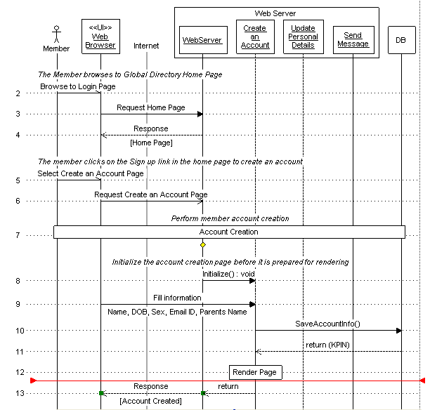

Update your personal Details

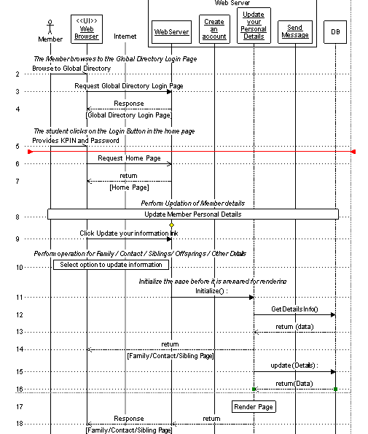

Screen Designs

Fingerprint – Scanner Form

Functionality
This form allows you to select the scanner to read the fingerprints from the database. You can select the fingerprint database and also the users’ database and can protect it with the password.

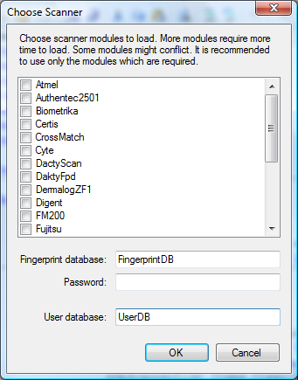

Fingerprint – Main Form

Functionality
This form allows you to enroll/verify the members’ fingerprint. And also you can delete user from the database. And you can change the Threshold values from settings form.
You can perform following operations:
• Enroll
• Verify
• Delete user
• Clear database
• Settings
With the purpose of enrolling a fingerprint to database a fingerprint scanner should be connected to a computer. The fingerprint is enrolled by pressing "Enroll".

When you need to verify a person's fingerprint with the one that was enrolled to a database select a database record and press the "Verify" button. After your fingerprint is scanned the verification is made. If the two fingerprints are identical, the matching score is shown. Otherwise, a message box announcing that fingerprints are not identical is shown.

Enrollment and Verification algorithm details are included in Fingerprint Algorithm section.

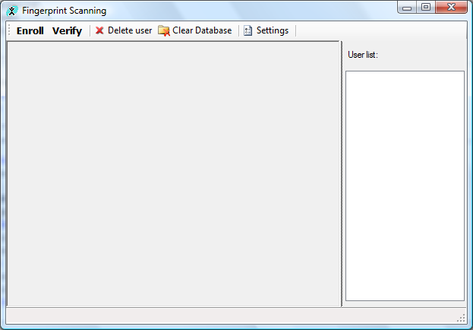

Login Page

Functionality
This page allows you to login into the Global Directory to access the personal information and to send Message to a group or to contact your friends.

The links available on the screen:

- Are you stuck?
If you forgot your password, you can click this link to recover your password. This will send your password to your Email Id.

- Sign up
A new member can join the Global Directory by providing the key information about him.

File Name:
GlobalDirectory.aspx

Tables used
S.No. | Table | Operation
 | MemberInfo | To check for the existence of a member

Validations
S.No. | Condition | Message
 | If Member has provided incorrect KPIN/password | *Invalid KPIN or Password

Assumptions and dependencies:
None

Master Page

Functionality
This page shows a Header on every page of the site. This shows the Name and KPIN of the member at the top of the page. Also provides the link to Log out from the Global Directory.
The Member information and Logout Link gets displayed in Header only if a Member is logged in the system.

The links available on the screen:

- Home
If you are on any page of site, then by clicking this link you can move to Home page.
- Privacy Practices
This highlights the privacy practices followed by owners of Global Directory to secure the information.
- Providers
It provides Information on Owners and establishing the concept behind Global Directory.
- Contact Us
It provides contact Information of Global Directory administrators and owners.
- Log out
It allows you to logout from Global Directory.

File Name:
Masterpage.Master

Tables used
S. No. | Table | Operation
 | MemberInfo | To show information of Member

Validations
S. No. | Condition | Message

Assumptions and dependencies:
None

Home Page

Functionality
This page shows your First/Middle/Last Name and Date of Birth as this information is not updateable. Also provides you an option to Search your friend and to update your personal details.

The links available on the screen:
- Update your Information
This link provides you an access to update your family details, contact details and so on.
- Link to KPIN
This link allows you to link your account with your close relatives account.
- Generate Reports
This link provides you an access to reports for study of population. Only Admin users can access this link.
- View your Mail Box
It allows you to view the mails sent by other Members of the group via the secured mechanism.
- Search a Member
This allows you to search your friend who is also the member of the Directory.
- View Family Tree
This link allows you to see your family tree (one level up and one level down). Also through the links on other page you can access the Family Tree of your relatives (if linked to your account).
- Upload your photo
This link allows you to upload photo.
- Change Password
You can change your password. No option to change your KPIN/Username.
- Admin
This link is visible only to the administrator of Global Directory to approve/reject request to send a message to a group.

File Name:
Memberinfo.aspx

Tables used
S.No. | Table | Operation
 | MemberInfo | To show Member details
 | AdminAccess | To check for Administrator accesses

Validations
S.No. | Condition | Message

Assumptions and dependencies:
None

Create your account

Functionality
This page allows you to create your account in the Global Directory by providing some basic information (Name, DOB, Sex, Email ID, and Parents Name).
When you click the Submit button to create account, then you will get a confirmation page (shows all information entered on previous page). If you click “Yes”, the your information will get saved and your KPIN is generated and an email is also send with details of KPIN and Password , and if you click “No”, you will be send back to the previous page to correct the information.
You have an option to generate the Simple/Complex KPIN. The logic for Complex KPIN generation is mentioned in the KPIN Algorithm section.

File Name:
MemberForm.aspx

Tables used
S.No. | Table | Operation
 | MemberInfo | To save Member details
 | FamilyDetails | To save Family Details (Parents information)
 | ContactDetails | To save contact information
 | OtherDetails | No information added. A blank record is created.

Validations
S.No. | Condition | Message
 | Length of First/Middle/Last Name, Parents’ Name < 2 | Initials not allowed. Use full name
 | First/Middle/Last Name, Parents’ Name contains characters other than Alphabets and space | Use only Alphabets and space
 | First/Last Name, Parents’ Name are not specified (Middle name is not Mandatory) | Please specify First/Last Name
 | Length of Name, Parents’ Name > 30 | Name can not have length greater than 30.
 | DOB is not correctly specified | Incorrect Date. Please specify correct Date of Birth
 | Email ID is in incorrect format | Incorrect EmailId. Please specify correct Email Id.
 | Length of Password < 8 | Password should be of atleast 8 characters.
 | Password is not equal to Confirm Password | Password should be same.

Assumptions and dependencies:
- Information entered by member is correct and accurate.
- System cannot check for the authenticity of the entered information.
- Regular Data verifications can be done to check for data authenticity.

Family Details

Functionality
This page allows you to provide your family details. You can provide following information:
- Parents Name
- Marital Status
- Spouse Name

If you select the marital status as married, then only you can specify the Spouse Name.

Note: On all the screens where you can update your personal information, there is a drop- down list from where you can select the type of information which can updated. The options available are
- Family Details
- Contact Details
- Sibling Details
- Offspring Details
- Deaths in family after 1989
- Births in family after 1989
- Other Details

File Name:
FamilyDetails.aspx

Tables used
S.No. | Table | Operation
 | FamilyDetails | To update the Family details

Validations
S.No. | Condition | Message
 | Validation on Father’s/Mother’s and Spouse Name | Validations and messages are same as defined in Name validation while creating an account.

Assumptions and dependencies:
None

Contact Details

Functionality
This page allows you to provide the contact details. You can provide following information:
- Native Address
- Permanent Address
- Current Address
- Mobile and Landline Phone number
- Email ID
If all the three addresses are same, then you don’t have to mention same address again. You need to provide information once and copy the same address by checking the checkbox.

File Name:
contactdetails.aspx

Tables used
S.No. | Table | Operation
 | Contact details | To store updated contact information

Validations
S.No. | Condition | Message
 | The length of Address < 70 | Address can not have length greater than 70.
 | The city, state and Country should contain only alphabets | It can have Alphabets and space only
 | Validation on Street | Street can have allows Alphabets, space and (-), (/), (\), (,).
 | Validation on Phone number | Mobile/Landline Number can have digits only.

Assumptions and dependencies:
None

Offspring Details

Functionality
This page allows you to provide the Offspring details. You can provide following information assuming each member will have a separate account.
- Name
- Sex
- Date of Birth

This page also shows the existing records saved by you and also provide the feature of adding/deleting the records.

File Name:
OffspringDetails.aspx

Tables used
S.No. | Table | Operation
 | MemberInfo | To update the last updated date information.
 | OffspringDetails | To store the updated Offspring Details

Validations
S.No. | Condition | Message
 | Validation on Name | Note: The checks which are applied on Name while creating the account are applicable.
 | DOB should be correct. | Incorrect Date. Please specify correct Date of Birth

Assumptions and dependencies:
None

Sibling Details

Functionality
This page allows you to provide the Sibling details. You can provide following information assuming each member will have a separate account.
- Name
- Sex
- Date of Birth

This page also shows the existing records saved by you and also provide the feature of adding/deleting the records.

File Name:
SiblingDetails.aspx

Tables used
S.No. | Table | Operation
 | MemberInfo | To update the last updated date information.
 | SiblingDetails | To store the updated Sibling Details

Validations
S.No. | Condition | Message
 | Validation on Name | Note: The checks which are applied on Name while creating the account are applicable.
 | DOB should be correct. | Incorrect Date. Please specify correct Date of Birth

Assumptions and dependencies:
None

Births in Family after 1989

Functionality
This page allows you to provide details of Births in Family after 1989. You need to specify Name, Sex, Date of Birth and Parents Name. Here the parent could be your sibling also as you are storing information of all births in your family and not only of your child.

This page also shows the existing records saved by you and also provide the feature of adding/deleting the records

File Name:
BirthDetails.aspx

Tables used
S.No. | Table | Operation
 | MemberInfo | To update the last updated date information.
 | Birthsafter1989 | To store updated details of Births in Family after 1989
 | SiblingDetails | To show Siblings in Parents Name
 | OffspringDetails | To show Offspring’s in Parents Name

Validations
S.No. | Condition | Message
 | Validation on Name | Note: The checks which are applied on Name while creating the account are applicable.
 | DOB should be correct. | Incorrect Date. Please specify correct Date of Birth

Assumptions and dependencies:
None

Deaths in Family after 1989

Functionality
This page allows you to provide details of Deaths in Family after 1989. You need to specify Name, Relation, Date of Birth and Reason and Date of death. Here the parent could be your sibling also as you are storing information of all deaths in your family and not only of your child.

This page also shows the existing records saved by you and also provide the feature of adding/deleting the records.

File Name:
DeathDetails.aspx

Tables used
S.No. | Table | Operation
 | MemberInfo | To update the last updated date information.
 | Deathsafter1989 | To store updated details of Deaths in Family after 1989
 | SiblingDetails | To show Siblings in Parents Name
 | OffspringDetails | To show Offspring’s in Parents Name

Validations
S.No. | Condition | Message
 | Validation on Name | Note: The checks which are applied on Name while creating the account are applicable.
 | DOB should be correct. | Incorrect Date. Please specify correct Date of Birth

Assumptions and dependencies:
None

Other Details

Functionality
This page allows you to store following information apart from the basic information.
- Migration Details
If you have migrated from your native place, then you can provide the Reason and date of Migration.
- Education Details
You can provide the Highest Degree, Passing Board/University, Year of Passing and Employment Status. If you are employee, then provide the professional details.
- Professional Details
You can provide information about your current employer like your income, current employer, profession, Years of Experience
- Property Details
You can update your property details. The property details are classified as per the property type: Agricultural, Residential, Commercial and Movable and provide property Specifications, Identification and cost.

File Name:
OtherDetails.aspx

Tables used
S.No. | Table | Operation
 | MemberInfo | To update the last updated date
 | OtherDetails | To update the Education, Migration and Professional details.
 | PropertyDetails | To update the Property details.

Validations
S.No. | Condition | Message
 | Check for Date of Migration | Incorrect Date. Please specify correct Date of Migration.
 | Check for Reason of Migration | It can have Alphabets, space, (.) and Round brackets.
 | Check for Highest Degree | It can have Alphabets, space, (.) and Round brackets.
 | Check for Year of Passing | Year of Passing is a numeric field
 | Check for Company | Company can have Alphabets, space, (.) and Round brackets.
 | Check for Year of Experience | Year of Experience is a numeric field

Assumptions and dependencies:
None

Change Password

Functionality
This page allows you to change password.

File Name:
changepassword.aspx

Tables used
S.No. | Table | Operation
 | MemberInfo | To save the updated password.

Validations
S.No. | Condition | Message
 | Length of Password < 8 | Password should be of at least 8 characters.
 | Password is not equal to Confirm Password | Password should be same.
 | The Username/KPIN should be correct. | Invalid KPIN. Please specify correct Username/KPIN

Assumptions and dependencies:
None

Forgot Password

Functionality
This page allows you to retrieve your password based on your KPIN. This will send you an email with your password. If you forgot your KPIN, then you need to send an email to System Administrator to get the KPIN.
The page opens up in a new window as a pop-up.

File Name:
Forgotpassword.aspx

Tables used
S.No. | Table | Operation
 | MemberInfo | To retrieve password.

Validations
S.No. | Condition | Message

Assumptions and dependencies:
- Member should know his Username/KPIN.

Search a Member

Functionality
This page allows you to search a member to show list of all members based on the specified filter criteria. You can define the query with maximum of three clauses and the filter criteria can be varied. The filer criteria/field can be First Name, Last Name, City, Country etc.
When you click the Search button, you can view list of members.

Sample Query which can be specified by a member
FirstName = “Saurav” AND
LastName = “GUPTA” OR
City=”Delhi”

File Name:
SearchDirectory.aspx

Tables used
S.No. | Table | Operation

Validations
S.No. | Condition | Message

Assumptions and dependencies:
None

Mail Box

Functionality
This page allows you to view the Mails sent to you by any other member. You can view the Name, City and country of the member and also the subject of the mail sent at your personal Email ID. This screen shows just the information about the person who sent you the email via Global directory.
You can reply via global directory only to his email by clicking the Hyperlink for that person.

You can delete the records from Inbox also

File Name:
InBox.aspx

Tables used
S.No. | Table | Operation
 | MemberInfo | To retrieve the Name based on KPIN
 | MailList | To retrieve the list of all mails received.

Validations
S.No. | Condition | Message

Assumptions and dependencies:
None

Constraints
- You can only reply to the mail via Global Directory only
- You cannot view your sent folder.

Send Message

Functionality
This page allows you to send message to a friend/Group listed. This screen shows list of all the members based on the search criteria defined in the previous screen. The list shows Name, city and country of the member.
You can send message to the complete group by clicking the “Send message to Group” Button.

File Name:
Displaymembers.aspx

Tables used
S.No. | Table | Operation
 | Information passed from previous screen in session

Validations
S.No. | Condition | Message

Assumptions and dependencies:
None

Send Mail

Functionality
This page allows you to send email to the selected member. You need to provide the Subject and the Message body and when you click send, an email is sent to a member from GlobalDirectory.com, thus hiding the sender’s information. If you are sending message to a group, then it will move to the basket of administrator for approval. If approved, then email is sent to the Group.

File Name:
SendMail.aspx

Tables used
S.No. | Table | Operation
1) | MailList | It stores the mail information

Validations
S.No. | Condition | Message

Assumptions and dependencies:
None

Approve/Reject Request

Functionality
This page allows administrator to approve/reject the request for sending message to a Group. The approval functionality is added to stop sending malicious messages to a Group.

You can view all the Requests which are pending for approval and also the approved/rejected requests. To avoid showing the complete list of requests, an administrator can archive the approved/rejected requests done before a particular date.

Pending request Section
This shows list of all Pending requests for approval/rejection of messages. You can view the body of the message by clicking the subject link. The Approval/Rejection button available for each pending record

Tables used
S.No. | Table | Operation
 | MemberInfo | To get Member detail for the user who has raised the request.
 | RequestforPublicMessage | To show all pending request and to update record after approval/rejection.

Validations
S.No. | Condition | Message

All request Section
This shows list of all requests pending for approval/rejection or approved/rejected status. You can view the body of the message by clicking the subject link. Also provides the link to archive the approved/rejected records based on the selected date.

Tables used
S.No. | Table | Operation
 | MemberInfo | To get Member detail for the user who has raised the request.
 | RequestforPublicMessage | To show all pending request and to update record after approval/rejection.
 | ArchivedRequests | To store the archived approved/rejected records

Validations
S.No. | Condition | Message

File Name:
Admin.aspx

Assumptions and dependencies:
- The records are periodically archived done by administrator. This is a Manual process.

Link to KPIN

Functionality
This page allows you to link you account to your relatives (Father, Mother, Spouse, Offsprings and Siblings). The linking is done based on entered Name and Date of Birth.

File Name:
LinktoKPIN.aspx and LinkKPIN.aspx

Tables used
S.No. | Table | Operation
1 | Family Details | Updates the PinId of Mother, Father and Spouse
2 | SiblingDetails | Updates the PinId of Sibling
3 | OffspringDetails | Updates the PinId of Offspring

Validations
S.No. | Condition | Message
1 | If Name and DOB doesn’t exist in Database | KPIN not found

Assumptions and dependencies:
None

Generate Reports

Functionality
This page allows you to generate report for population statistics and thus help in analyzing the living standard of that community.

File Name:
GenerateReports.aspx

Tables used
S.No. | Table | Operation
1 | MemberInfo | Get count of all members based on different parameters/criteria

Validations
S.No. | Condition | Message

Assumptions and dependencies:
None

View Family Tree

Functionality
This page allows you to view the family tree of your family (one level up and one level down). This page will show the basic details of Father, Siblings and Offsprings. The link on the Org chart allows you to view the org chart of your relatives as well but only if you have linked them to their accounts.

File Name:
OrgChart.aspx

Tables used
S.No. | Table | Operation
1 | Family Details | Get Family Details
2 | SiblingDetails | Get Sibling Details
3 | OffspringDetails | Get Offspring Details
4 | MemberInfo | Get self details

Validations
S.No. | Condition | Message

Assumptions and dependencies:
None

Upload your photo

Functionality
This page allows you to upload your photo.

File Name:
Upload.aspx

Tables used
S.No. | Table | Operation
1 | Images | The photo is stored in Database

Validations
S.No. | Condition | Message

Assumptions and dependencies:
None

Error Page

Functionality
If an error due to any error, then you are directed to this page and it shows you the following error message ” An unexpected error has occurred, please try again and if problem persists, contact System Administrator for further assistance.”. This allows you to send message to System administrator by sending an email notification.

Tables used
S.No. | Table | Operation

Validations
S.No. | Condition | Message

File Name:
Errors.aspx

Assumptions and dependencies:
None

Screenshots

Login Page

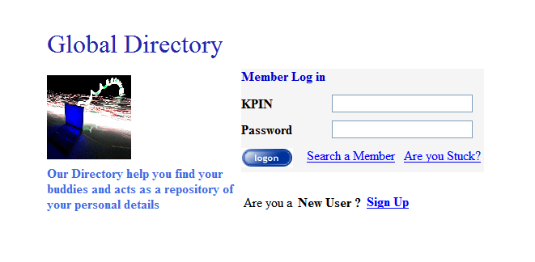

Header/Master Page

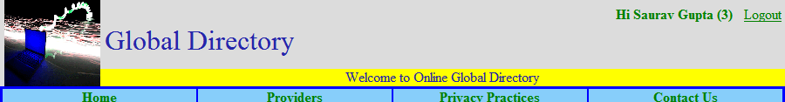

Home Page

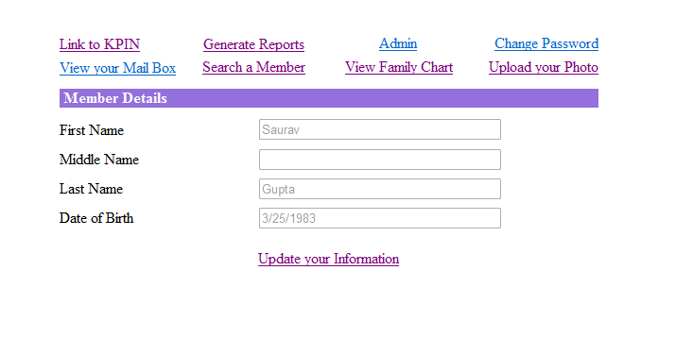

Family Details

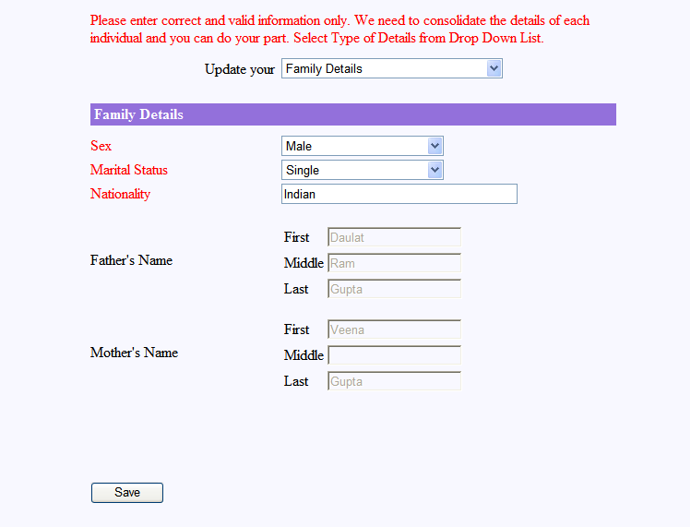

Sibling Details

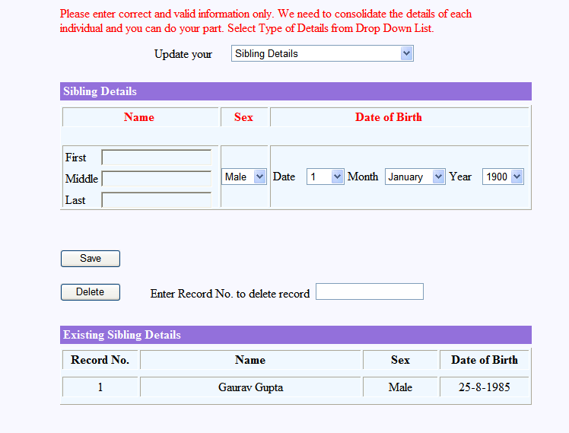

Search a Member

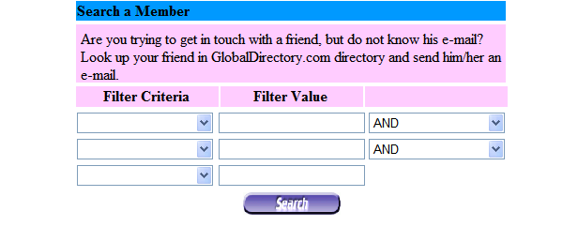

Create new account

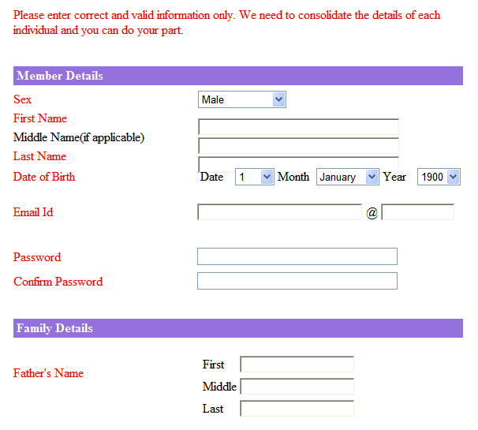

When you click, the submit button on create account button, you will get the following screen to verify information and choose whether you would like to have Simple/Complex KPIN.

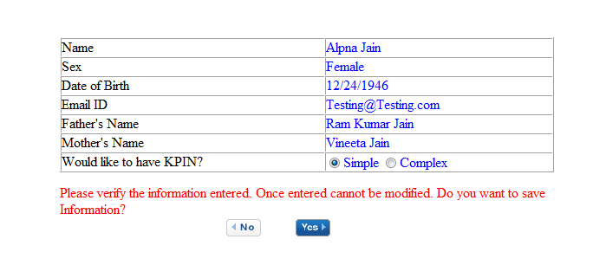
When you click on Complex, the KPIN is generated based on presented algorithm.

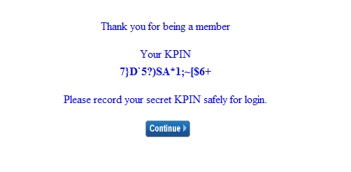

Upload your photo



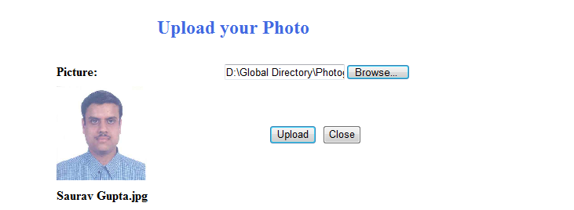

Org chart

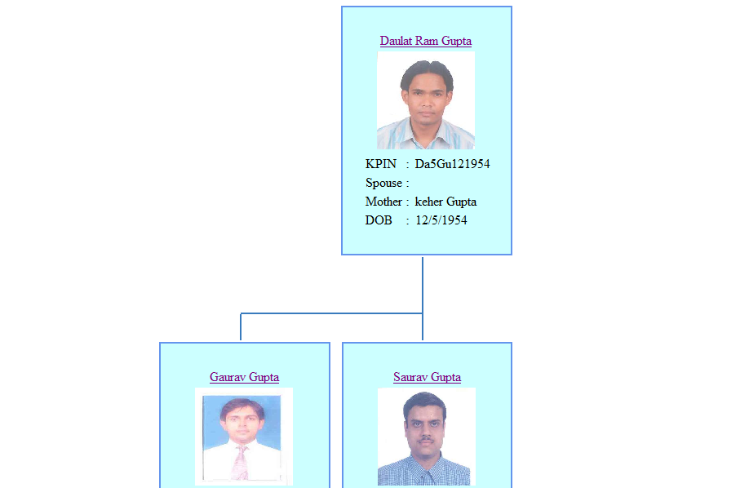

Link KPIN

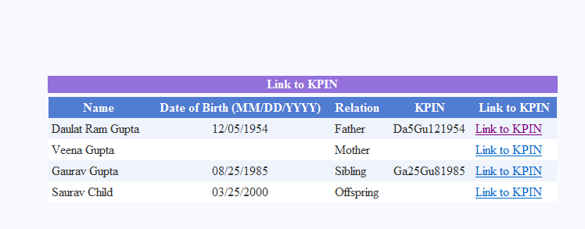

On click of Link to KPIN

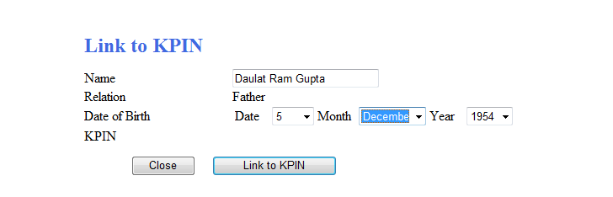

Sample Report
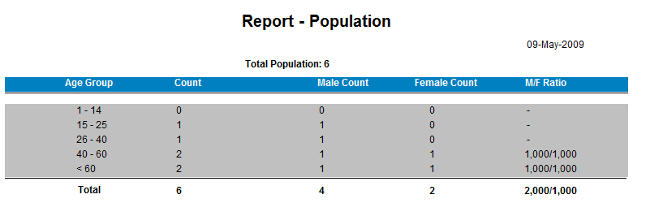

Secured Communications

The Global Directory provides a platform to contact your friends or to search a member based on different filter criteria’s like First Name, Last Name, City and Country. Under the internet age, Email is the easiest and the fastest way of communication. The best part of this communication is that it is totally secured, that is all communication takes place under the secured environment of Global Directory.

You can send a message/email to another member via Global Directory and you need not to share any Contact information that is even without sharing your personal Email IDs. The Global Directory also provides you an option to send a message to a group, equivalent to broadcasting a message.

Message to an Individual

For sending a message to an individual, you need to search that member on the portal based on the defined criteria’s. When you search a member, then you can see the list of all members meeting the search criteria. On the same page, you will find a link to send a message to the selected member.

Now provide the Subject and Message body of the Email to be sent to another member. When you click the send button, then an email is sent to the member with the TO field as “GlobalDirectory.com” and also the entry gets appeared in the Inbox of the other member so that the other member can reply the email.

The Email sent by other member via Global Directory portal, will come to your personal mail box but you cannot reply to that Email as the mail was sent by GlobalDirectory.com But you can reply to the email by visiting your Inbox on the portal. Your Inbox will display the Name, city and country of the sender, Mail received date and the Subject of the mail so that you can identify the mail for reply. Now select the Mail to be replied and provide the subject and message and send reply to the member

Note: For sending mail to an individual, no approval from administrator is required.

Message to a Group

Another use of Global Directory is broadcasting message to a Group based on the filter criteria.
For sending a message to group, you need to search that member on the portal based on the defined criteria’s. When you search, then you can see the list of all members meeting the search criteria. On the same page, you will find a button “Send message to Group” to send a message to all the members.

Now provide the Subject and Message body of the Email to be sent to another member. When you click the send button, then your request is sent to Administrator for approval. The approval level is added to avoid/restrict users from sending any malicious or useless messages. If an administrator approves the request, then an email is sent to the member list with the TO field as “GlobalDirectory.com” and also the entry gets appeared in the Inbox of the members so that the other member can reply to the email if required.

The broadcasted message sent via Global Directory portal, will come to your personal mail box but you cannot reply to that Email as the mail was sent by GlobalDirectory.com But you can reply to the email by visiting your Inbox on the portal. Your Inbox will display the Name, city and country of the sender, Mail received date and the Subject of the mail so that you can identify the mail for reply. Now select the Mail to be replied and provide the subject and message and send reply to the sender.

Note: For sending mail to a group, an approval from administrator is required.

Applications

The Global Directory designed is just the beginning of era as the portal can be enhanced so that we can use the portal for several different purposes and can be prove to be an asset. Few of the applications or area of usage is defined as

- Census:
The data collected can be used by the Government of India for census purposes. Under the internet age, once the data is manually collected and can be tracked for lifetime and also provide a medium for the members to update it regularly.
- Data Analysis:
You can also use the data collected for analysis purposes like to find the average age of the community, the literacy rate, the Employment Status or the standard of living.
- Communication:
The secured mechanism allows you to broadcast message to a group/community under emergency circumstances.
- Contact a friend:
It also provides you a feature to find your lost friend and establishing contact with him by searching over the portal. Even if you have migrated from one place to another but still you can be in touch with your friend as it searches based on your native place.
- The portal can be used to generate a report of all your ancestors and can generate the family graph.

Salient Features

- Requires less data storage space
Considering that we are planning to store the information in compressed format, less data space is required in the database.

- Provides High data security
The Access to personal data is restricted by KPIN and password and can only be updated by the member only. The communication via a secured mechanism ensures that no personal/contact details are disclosed to establish relationship.

- Scalable
The Global Directory portal can be extended up to any level and data can be collected for Community, society, city or country.

- Available Online
Under the internet, the best way to enter/provide details online. You can provide all required details just sitting at home and within the reach of every individual

- Easy to use
The portal is very easy to use as appropriate messages and basic data information is collected. With the enhanced features, the Help functionality can be added to make it easier for user.

Conclusion

The project Global Directory is completed with satisfaction. The algorithm for KPIN generation still requires attention as it doesn’t provide the high level of compression as expected. But the applications and real time usage of the portal make it very useful for every group and will find it usage in every field.

